Week 4 Course Project:

Analysis and Design

Anthony Meunier

DeVry University

CIS 355A

Request for New Application

|  |  |
| --- | --- |
| Request Date | August 1, 2015 |
| Requester Name | Anthony Meunier |
| Purpose of Request | The purpose of the request is to create a GUI application that will take in the order details, calculate flooring cost, and the store/display the results. |
| Title of Application | Flooring GUI Application |
| Description | Flooring GUI application will calculate the area of the flooring and the cost of the flooring as per the customer order details. All details are saved in the database for later viewing. |

Problem Analysis

The problem is to create a program that aids in tracking customer orders and calculates the flooring cost, and then stores the orders in the database.

In order to meet this criteria and develop an answer to the problem we will create a GUI with three tabs. The first tab will allow customer details to be entered, the second tab will be used for inputting the flooring details, and the third tab will be used to display the results.

List and Description of the Requirements

* A GUI will be created where user will input customer details and order details. Text fields, labels, and radio boxes will be added and used in the interface.
* Application will compute the area of the flooring and cost of the flooring when calculate button is clicked based on the values entered by the user; results will then be displayed in a new tab with correct/appropriate formatting.
* All information entered by the user is validated.
* All information will be saved in the database.

Interface Storyboard/Drawing

Customer Info/General Tab:

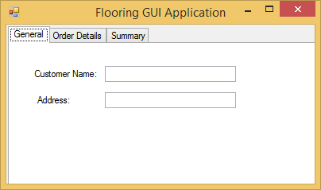

Flooring/Order Details Tab:

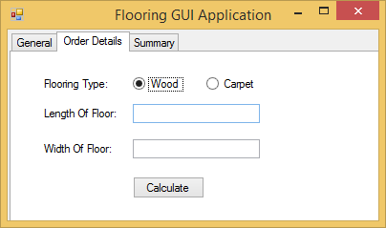

Summary/Results Tab:

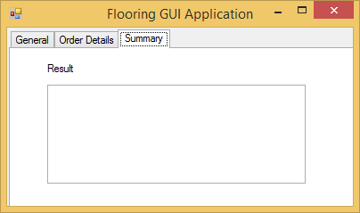

Design Flowchart

